Task 1



| **Command** | **What It Does** |
| --- | --- |
| whoami | Shows the username of the currently logged-in user. |
| uname -a | Displays detailed information about the system (kernel version, architecture, OS type). |
| cd /projects | Changes the current directory to /projects. |
| ls -l | Lists files and directories in the current folder with detailed permissions, ownership, and timestamps. |
| mkdir projectB | Creates a new directory named projectB inside /projects. |
| ls -l | Again lists files/directories to confirm that projectB was created. |
| touch projectB/README.txt | Creates an empty file called README.txt inside projectB. |
| echo "Welcome to Project B" > projectB/README.txt | Writes "Welcome to Project B" into the README.txt file (overwriting if it exists). |
| cat projectB/README.txt | Displays the contents of README.txt on the screen. |

Task 2

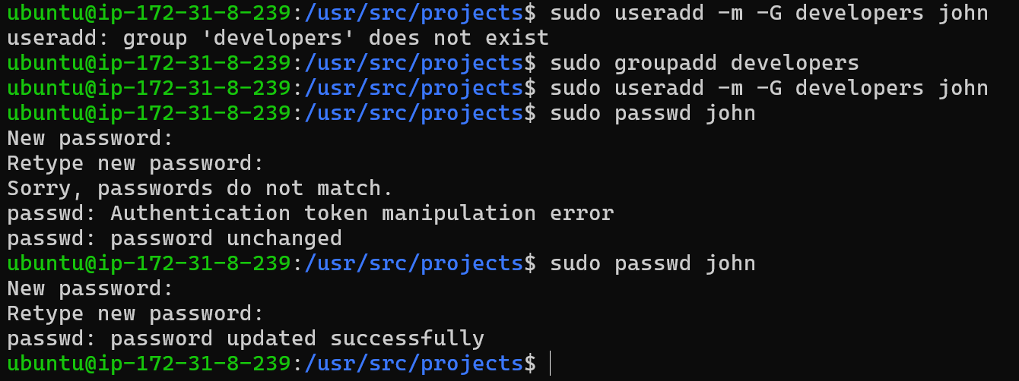

\





| **Command** | **What It Does** |
| --- | --- |
| sudo useradd -m -G developers john | Creates a new user john with a home directory and adds him to the developers group. |
| sudo passwd john | Sets (and confirms) the password for user john. |
| id john | Shows user ID, group ID, and all groups that john belongs to. |
| sudo chown :developers /projects/projectB | Changes the **group ownership** of projectB to developers (the group). |
| sudo chmod 770 /projects/projectB | Sets permissions so only the owner and group members can read/write/execute inside projectB — others have no access. |
| ls -ld /projects/projectB | Lists the permissions, owner, and group info of projectB directory in long format. |

Task 3: Changing File Ownership



| **Command** | **What It Does** |
| --- | --- |
| sudo chown john:developers /projects/projectB | Changes both the **owner** of projectB to john and **group** to developers. |
| ls -ld /projects/projectB | Lists and confirms that john is now the owner of projectB. |

Task 4: System-Level Monitoring Commands



| **Command** | **What It Does** |
| --- | --- |
| uptime | Shows how long the system has been running, number of users, and system load averages. |
| df -h | Displays disk usage information for all mounted filesystems in human-readable format (MB, GB). |
| free -m | Shows the system’s memory (RAM) usage in megabytes (MB). |
| ps aux --sort=-%mem | head -5 | Lists processes sorted by highest memory usage and shows the top 5 memory-consuming processes. |